Ulvi Bajarani

SID 20539914

CSCI 6345 – Advanced Computer Networks

Summer II

Assignment 10

Working on Group Policy elements in Windows Server

To enter into the Group Policy Management, we choose Tools → Group Policy Management from Server Manager:

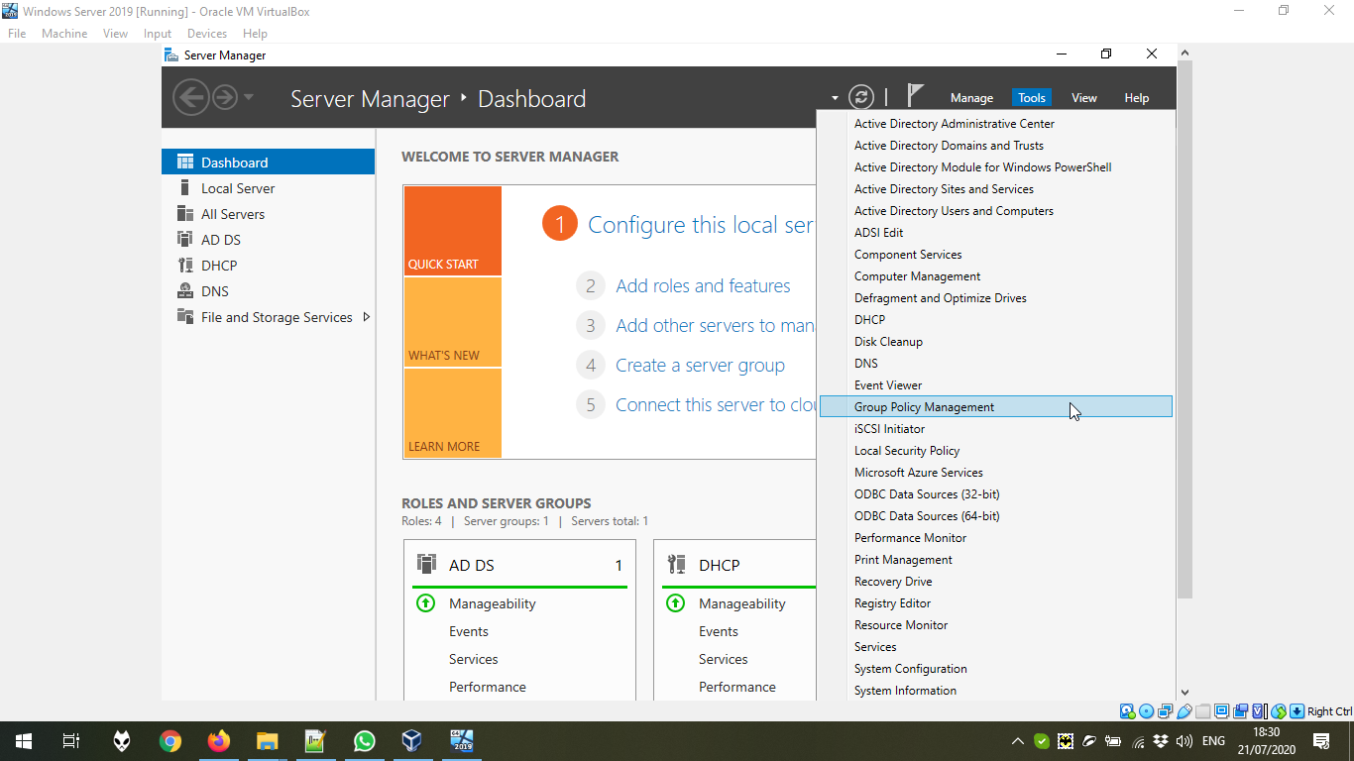

Here, we can see all possible Group Policy Objects, folders, and Organisational Units. Remember that only Organizational Units can have their own Domain Policies.

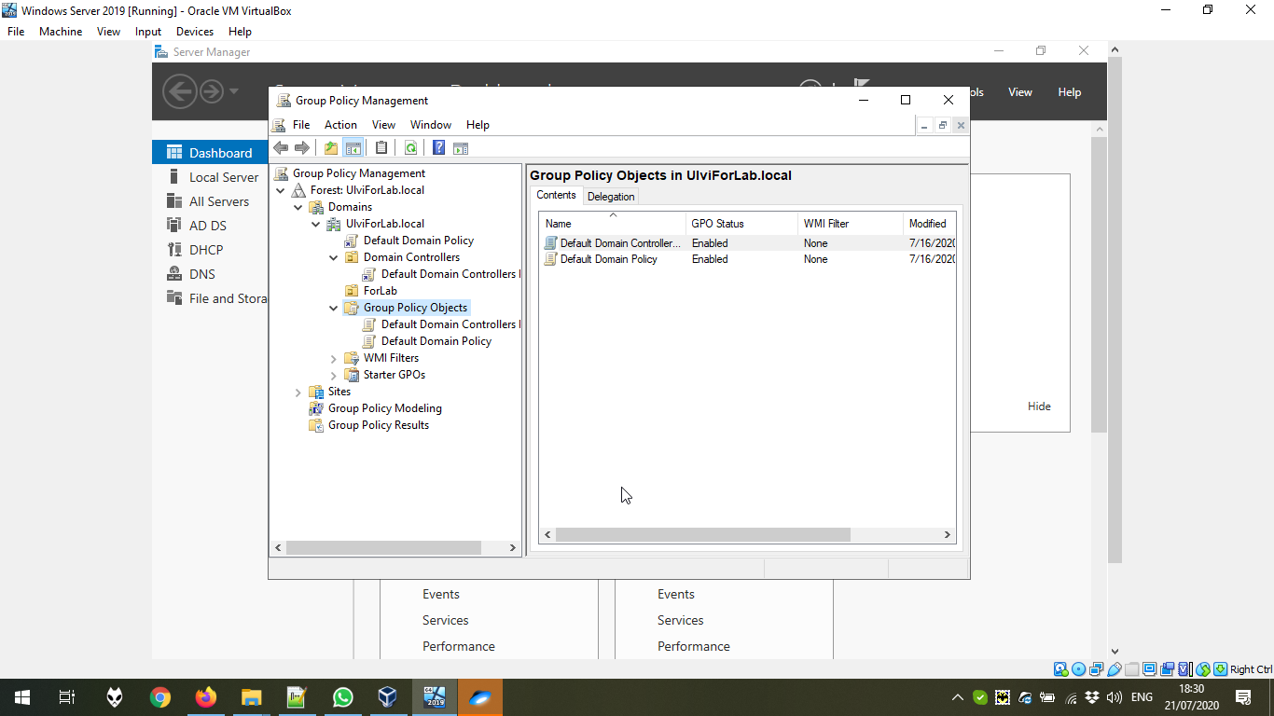

Let’s create a GPO (Group Policy Object) in the ForLab and link it to the folder:

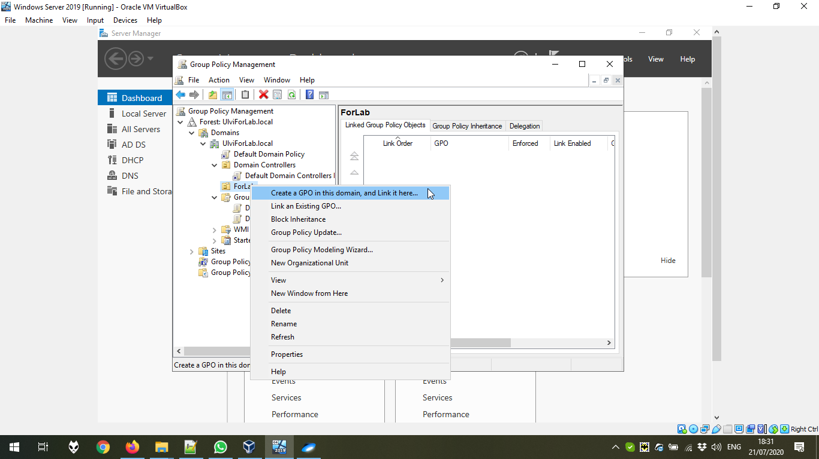

We give the name:

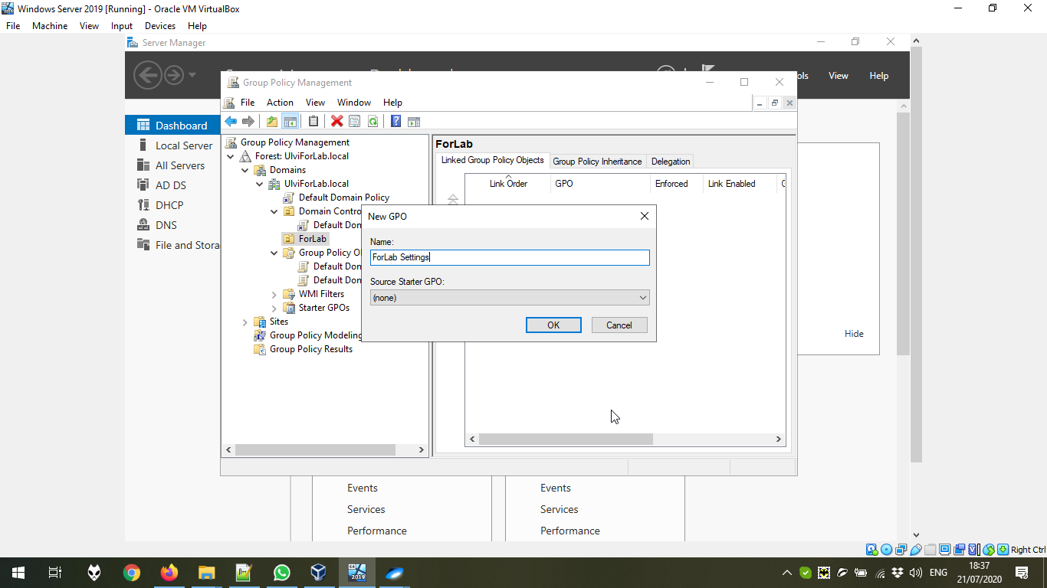

Now, we can see both shortcut in the ForLab and the policy in the Objects:

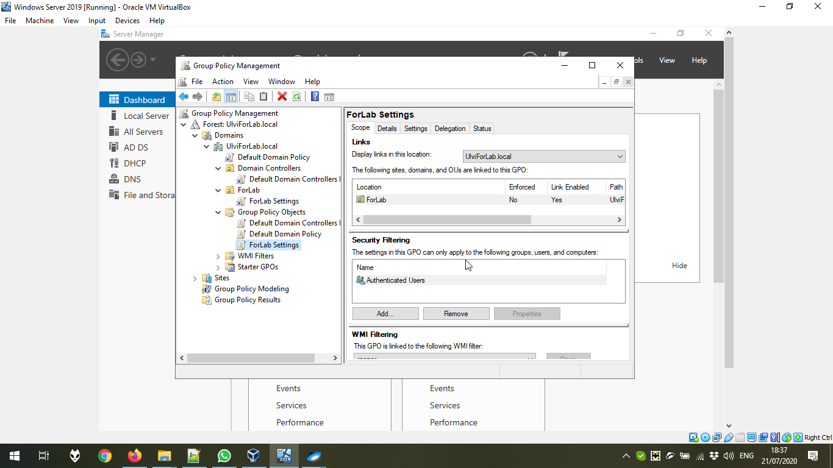

Another possible way to see is to get the access to the computer from run by \\<Domain name>:

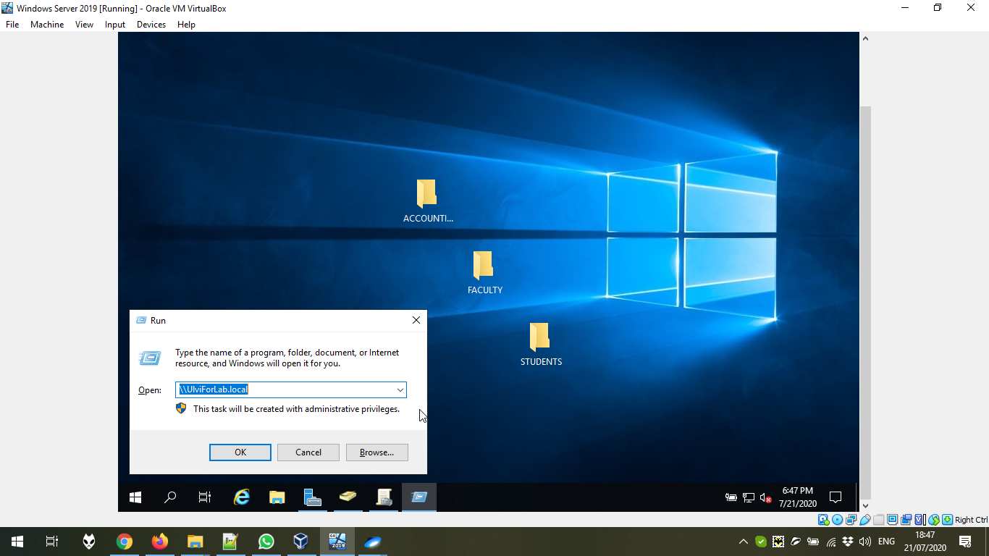

Now, we can see the folder SYSVOL that contains all policies and scripts of all domains:

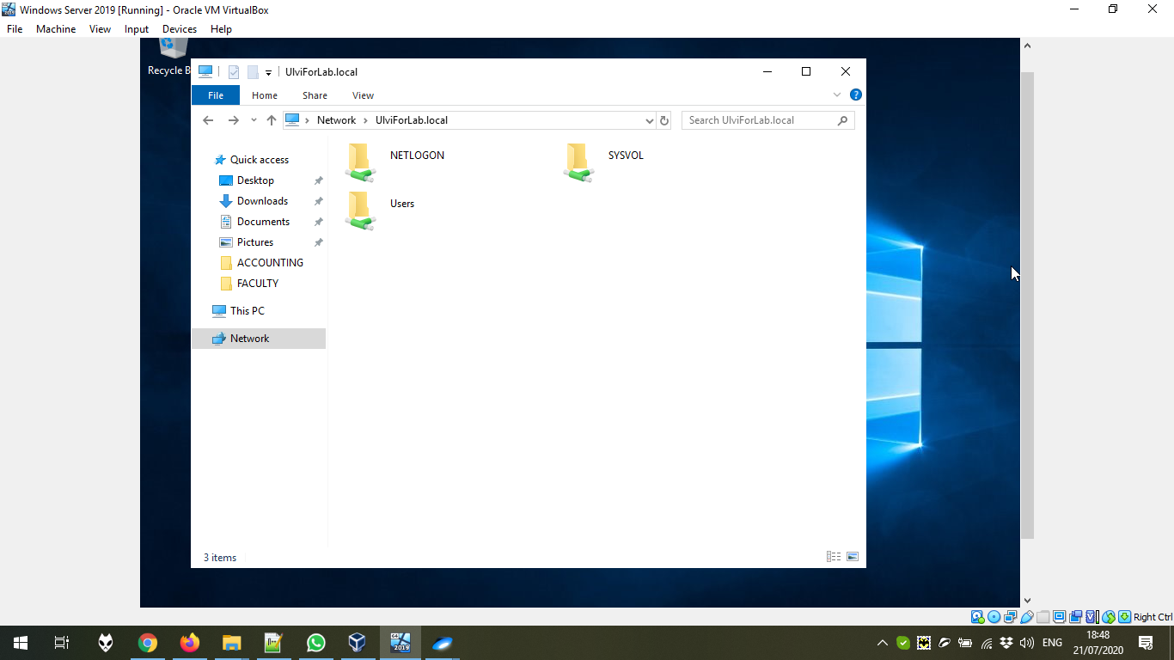

Enter to the domain:

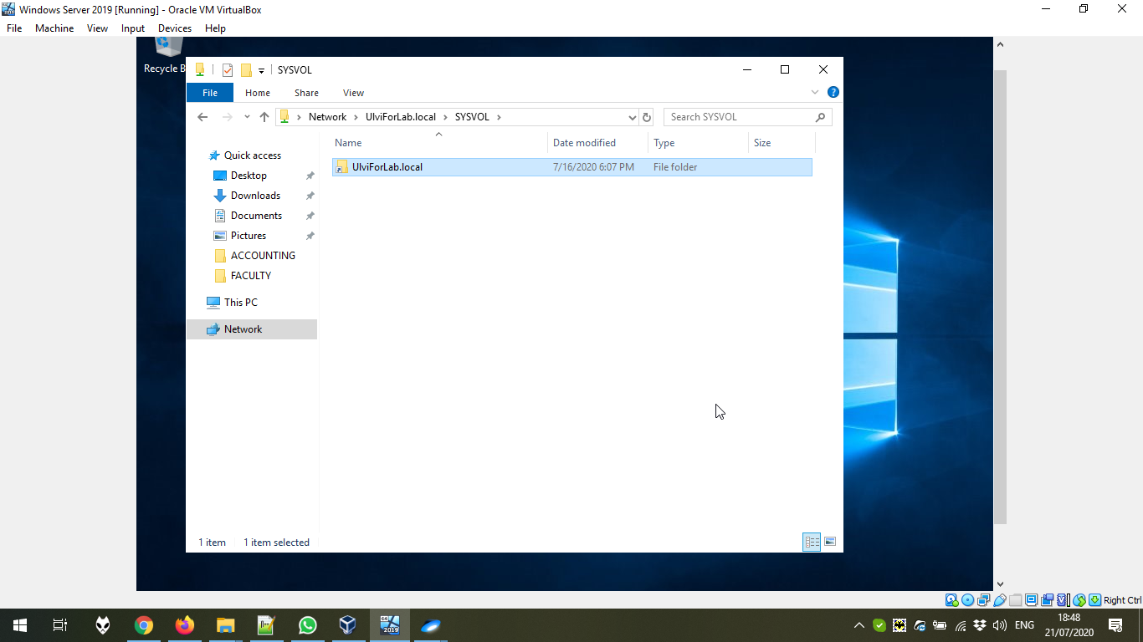

Now, both Policies and scripts are exist:

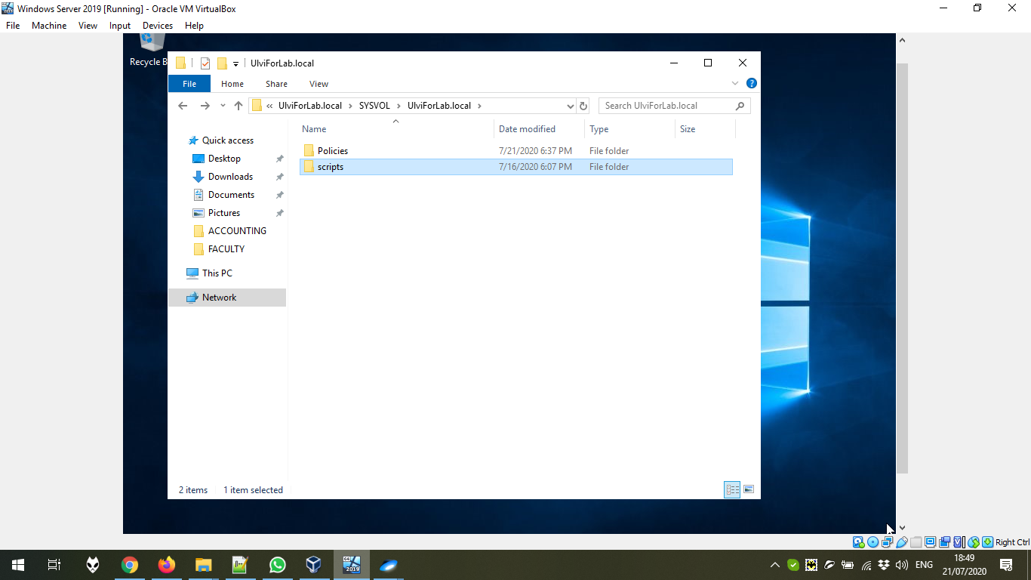

The folders of some Policy (To differ the machine and user options), and the file with specific records.

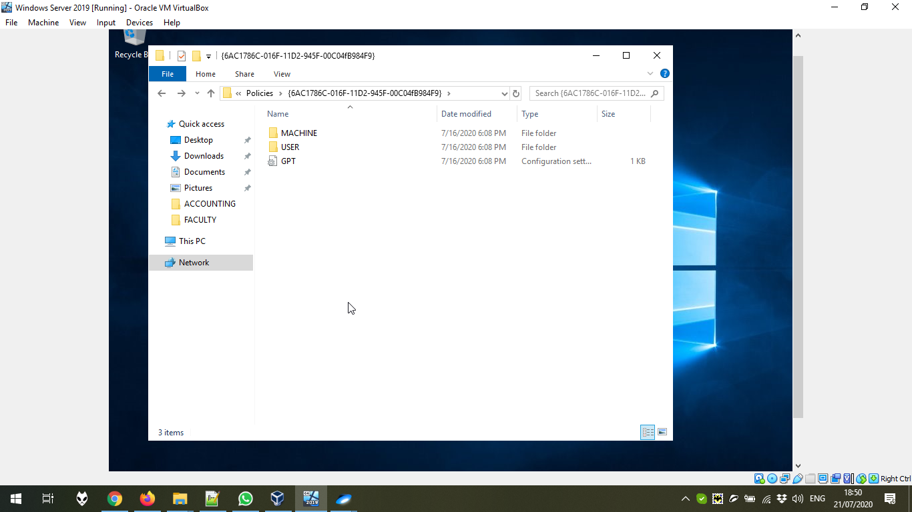

Another way to control other computers is using side-ins. We can do it by Microsoft Management Console. We can get there by **mmc** command in Run.

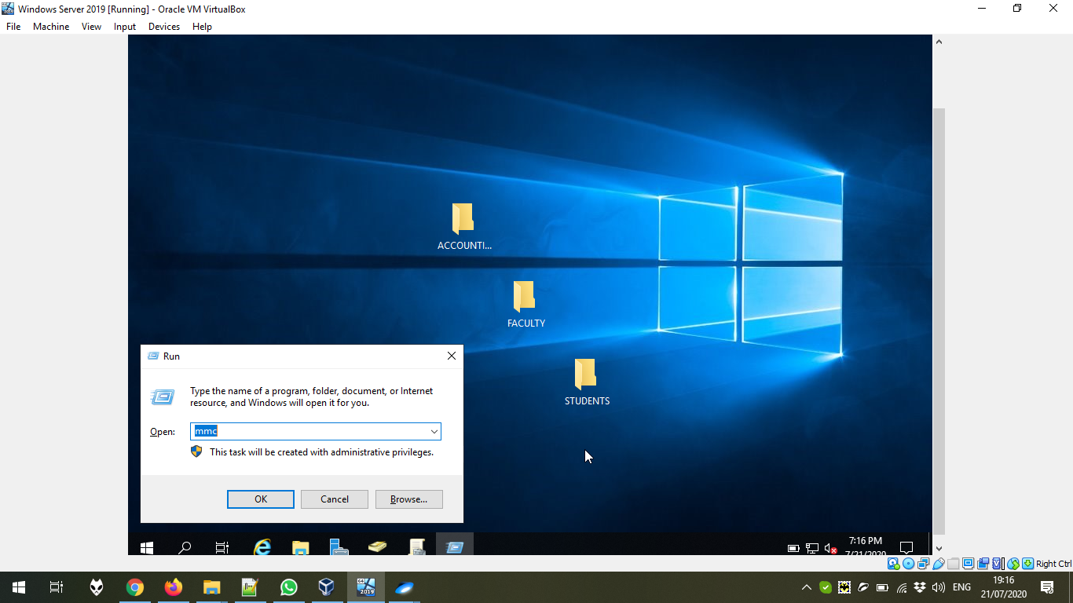

The Console Root is empty. We go to File → Add/Remove Snap-in… to add some snap in:

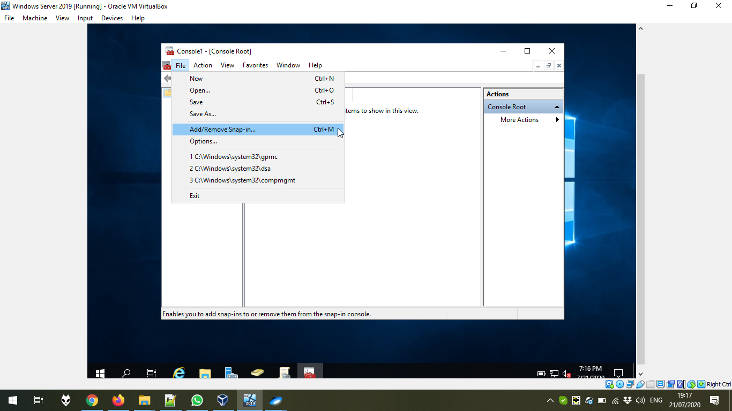

For example, we choose Local Users and Groups:

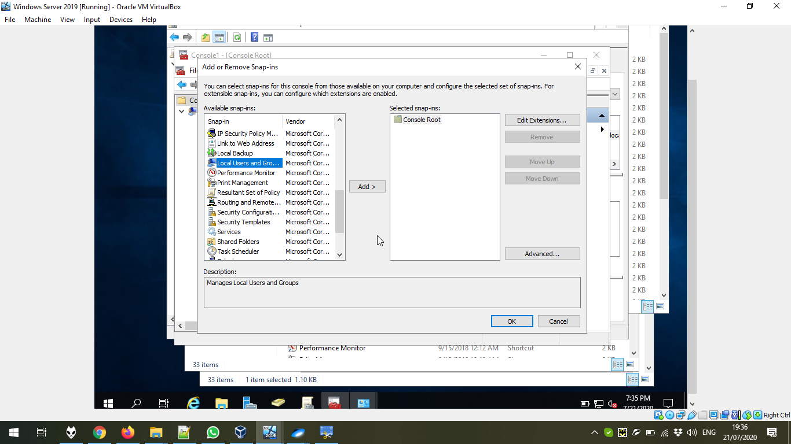

Here, we add the name of our Computer connected to the domain:

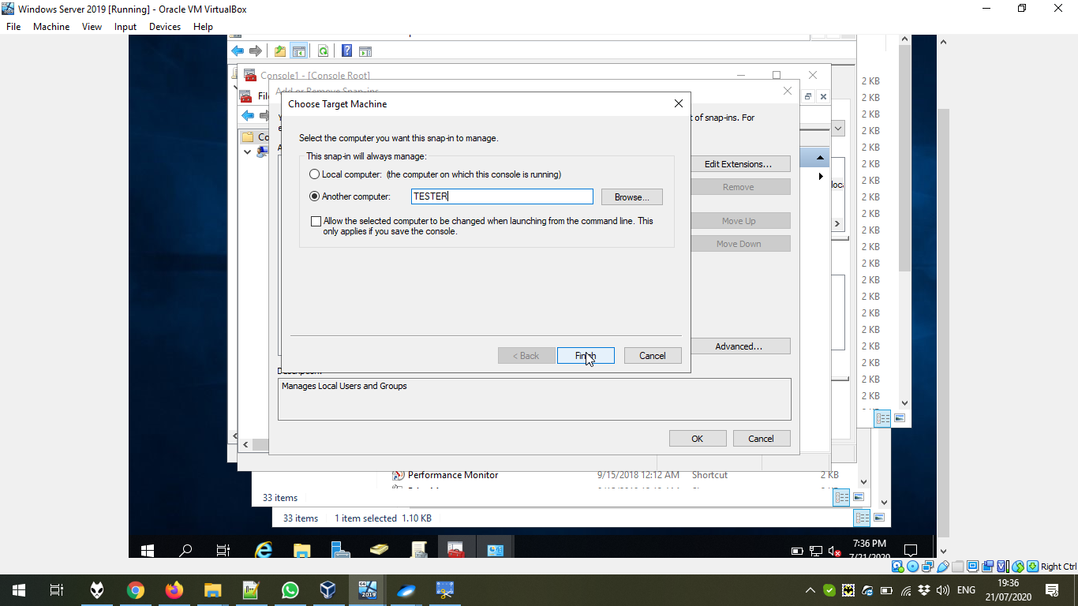

Now, we press OK:

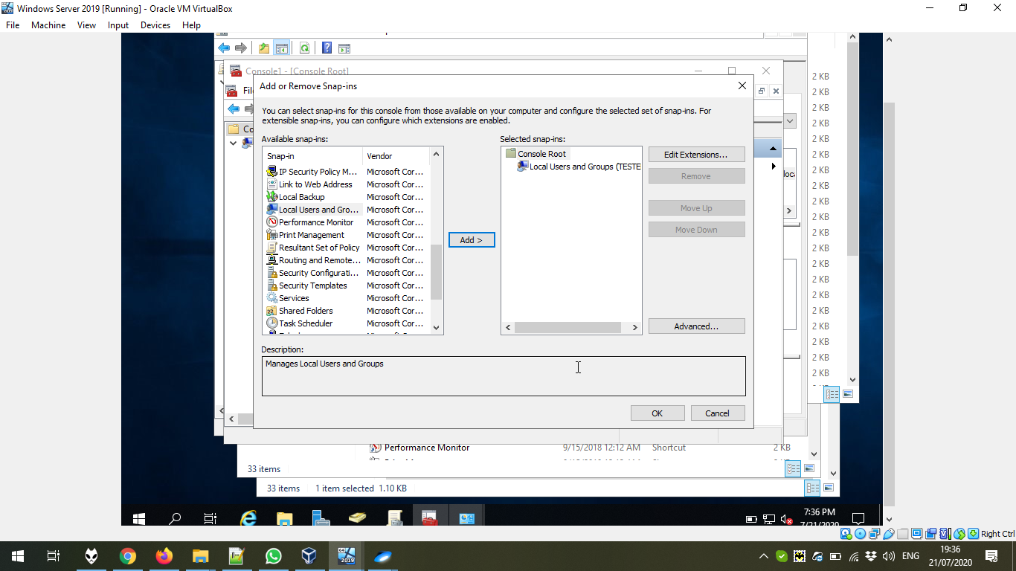

Now, we can see the users list of TESTER:

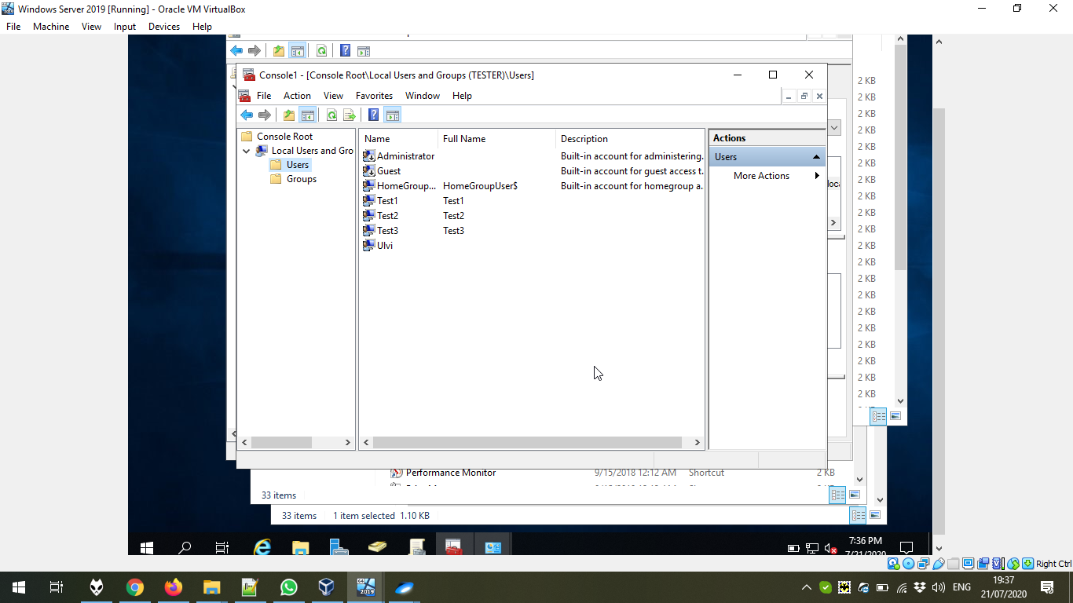

Let’s edit the Policy “ForLab Settings”:

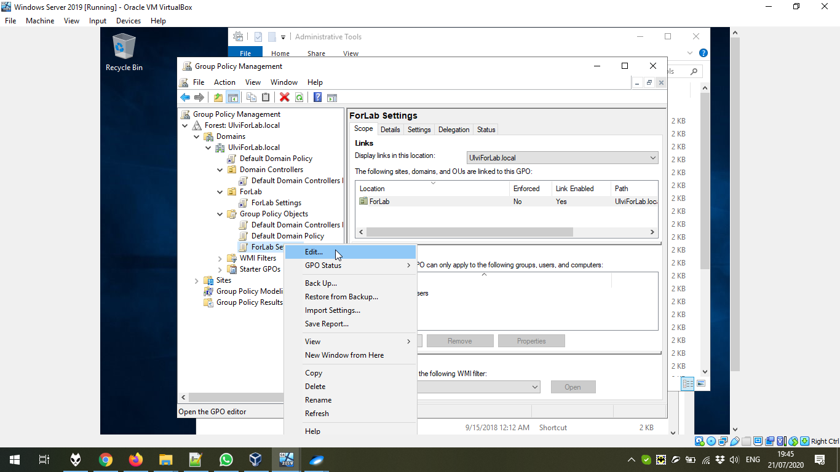

Here, we can see both Computer Configuration and User Configuration. The difference is in the case that User is for users, but computer for the machine. For example, some preferences might be specific for users in the Organisational Unit, but not for the Machine Organisational Unit.

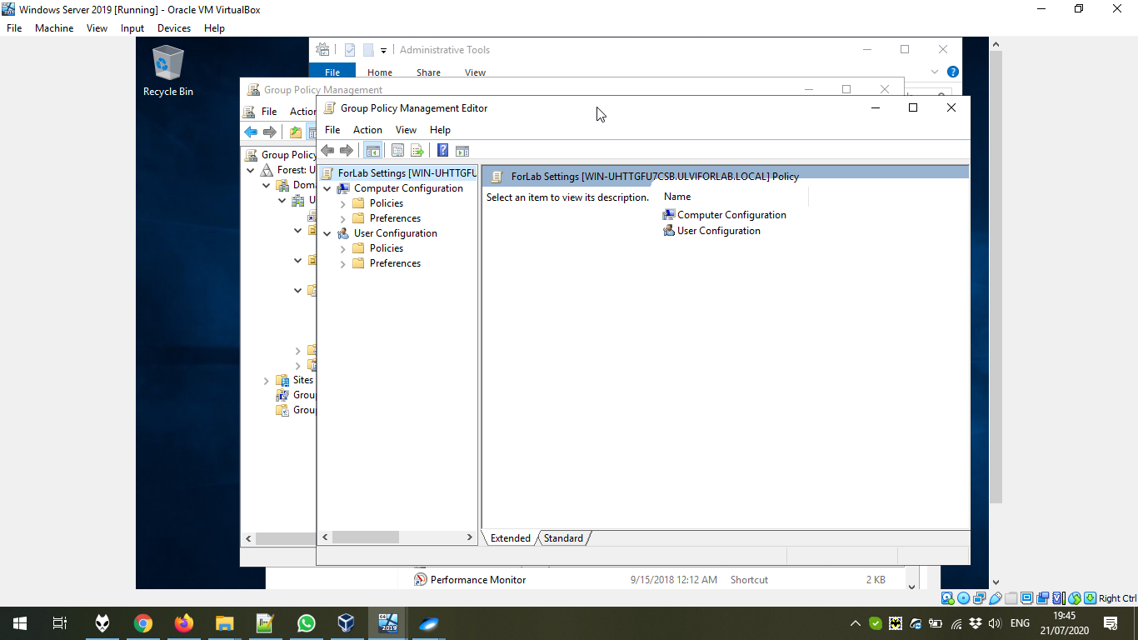

Now, let’s create the installation policy. For the task, I have downloaded Adobe Reader and created the folder to share:

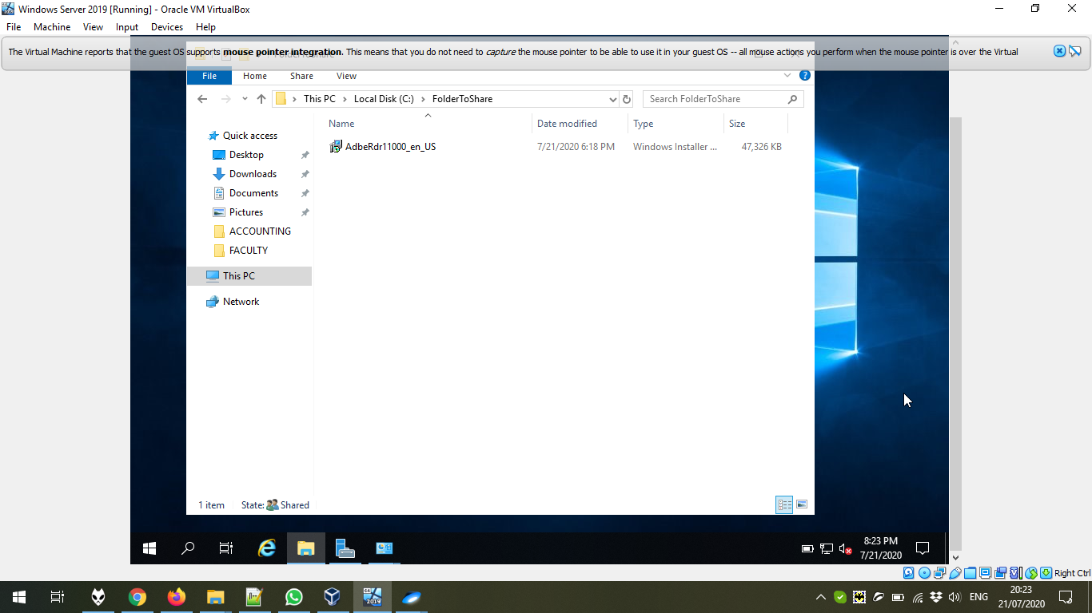

Let’s go to the Properties:

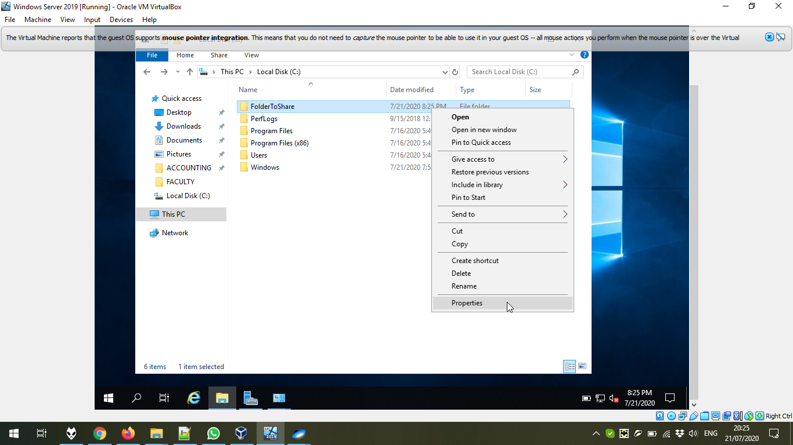

Press Advanced Sharing:

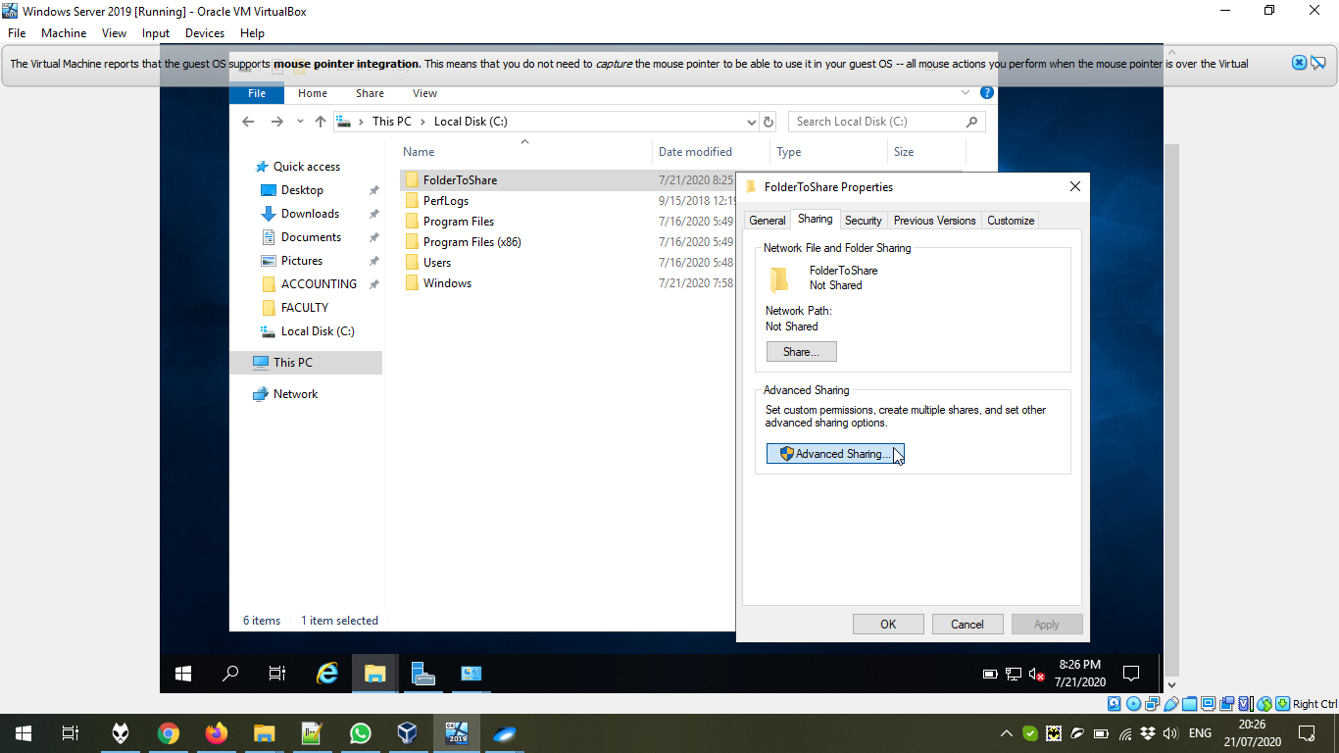

Define the name. To install, it is recommended to add $ sign at the end of the share name:

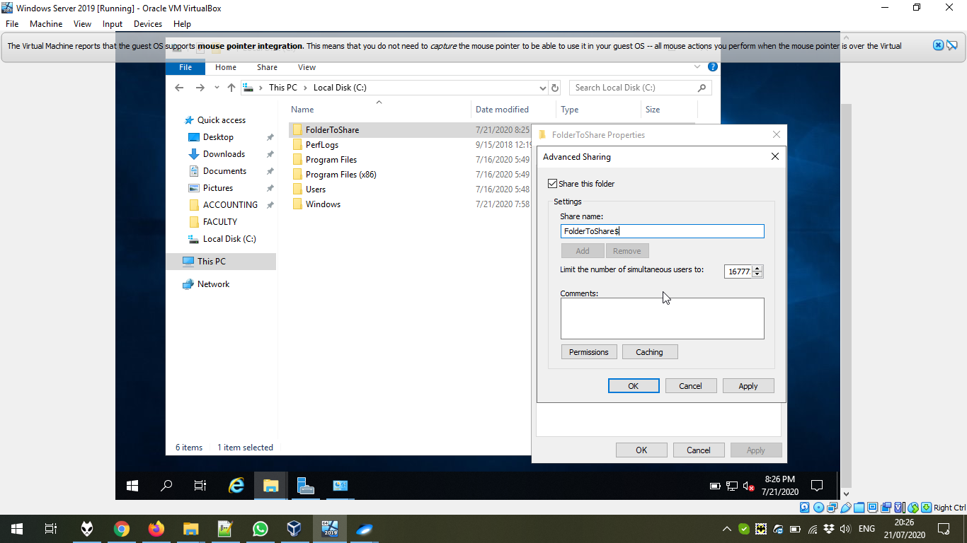

Now, let’s move to the Tools → Group Policy Management:

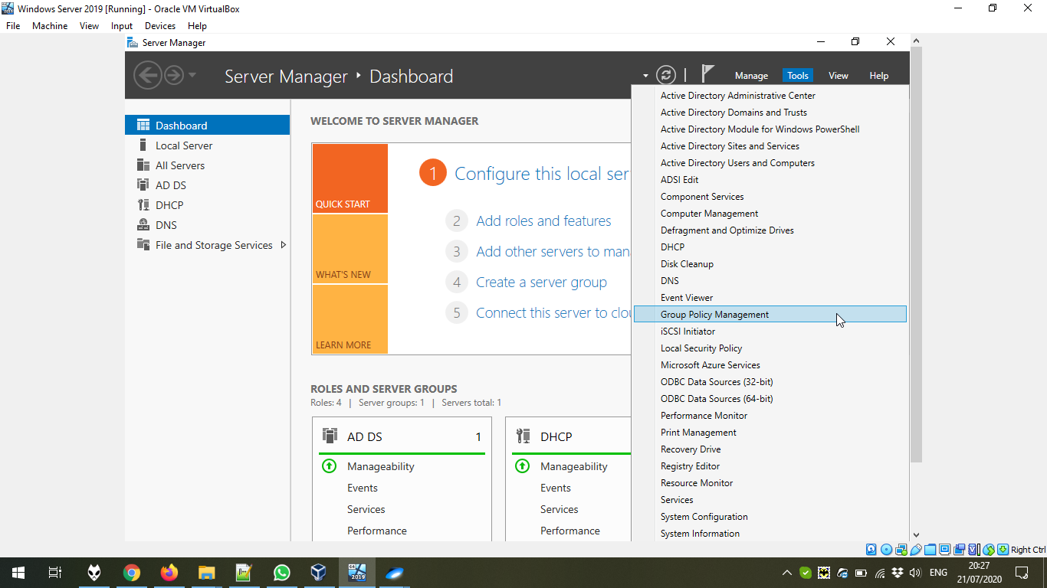

We created two folders: one with computers, another with users and Security Groups. We create the Group Policy Object for computers.

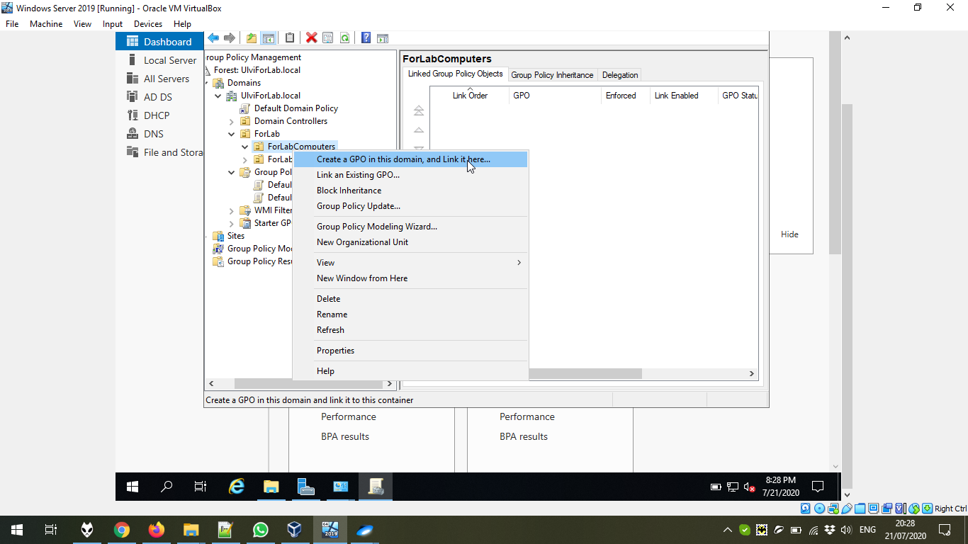

We give the name Software Deployment Settings:

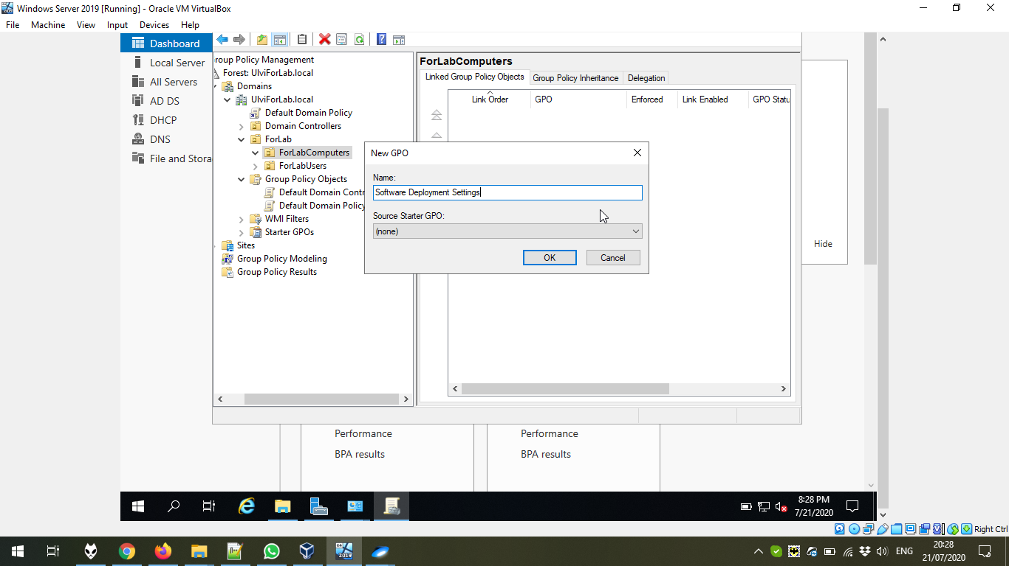

Now, we edit the policy:

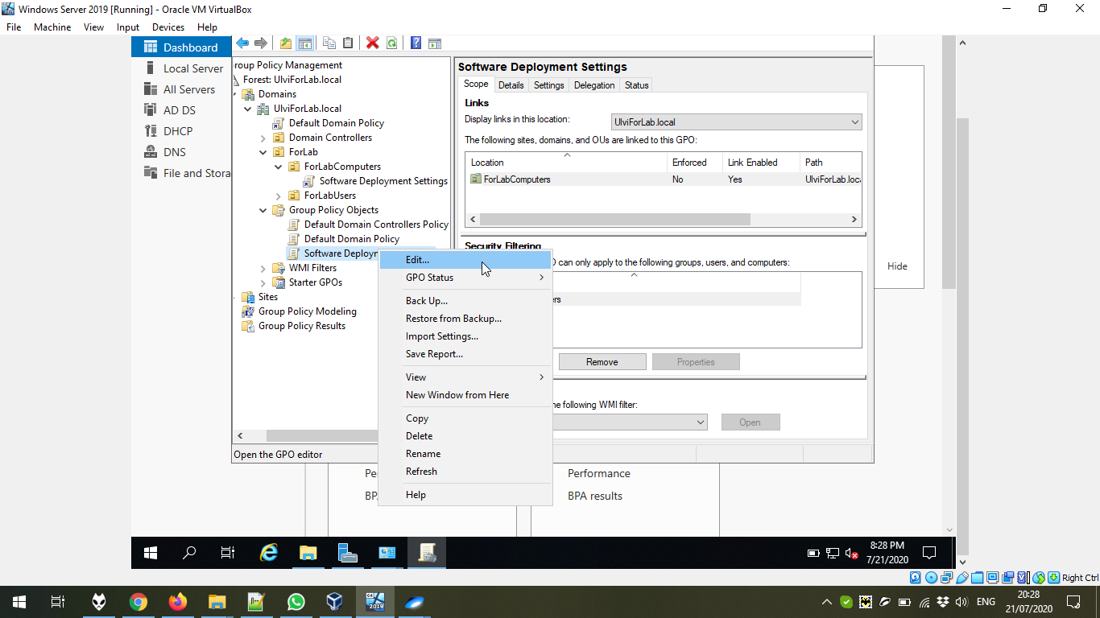

In the Computer Configuration → Policies → Software Settings → Software Installation we create a new Package by New → Package:

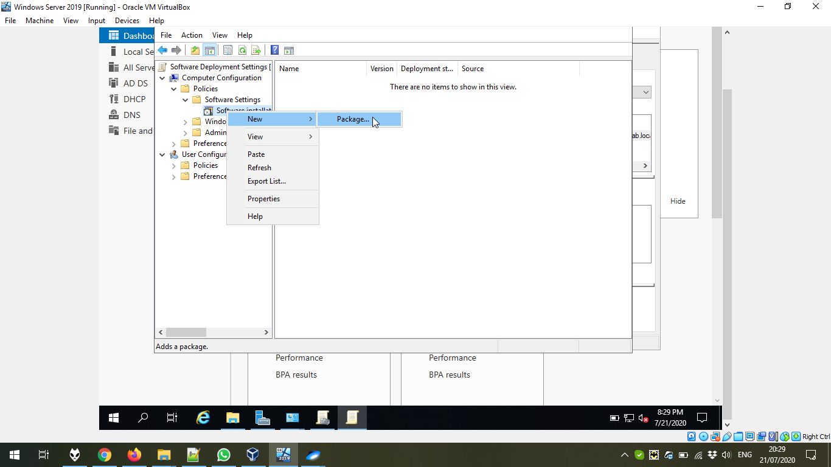

Then, we go to the remote folder (it is important, because only shared content is available for computers)

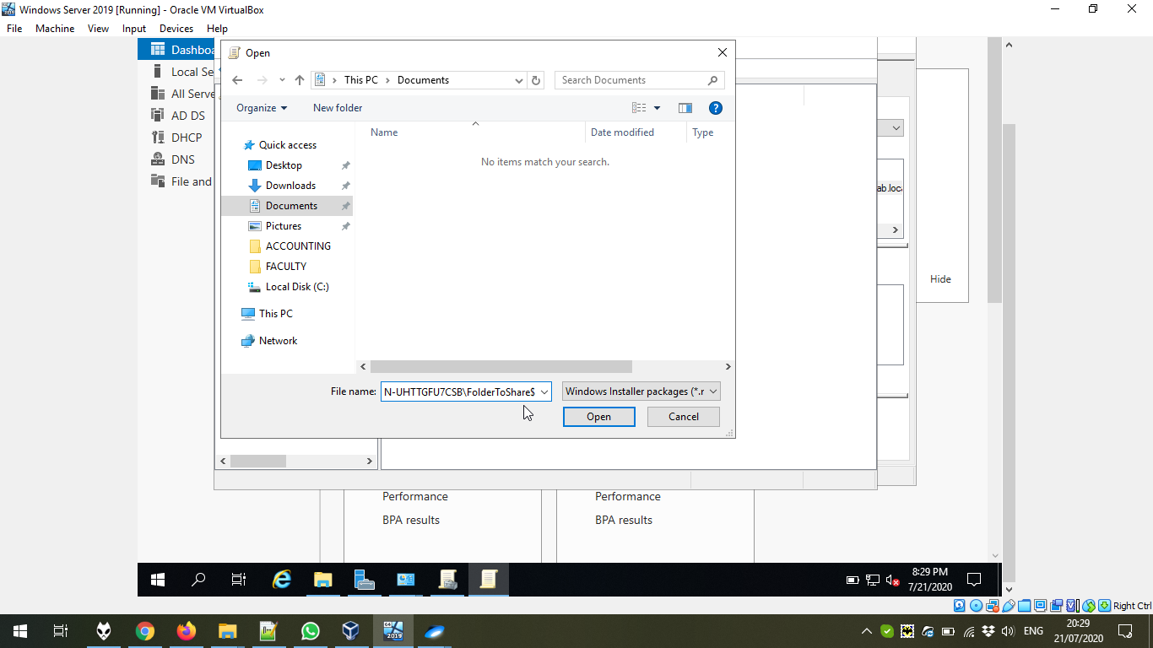

After choosing, we can deploy Assigned, or Advanced. We don’t need the specific options, so Assigned is OK:

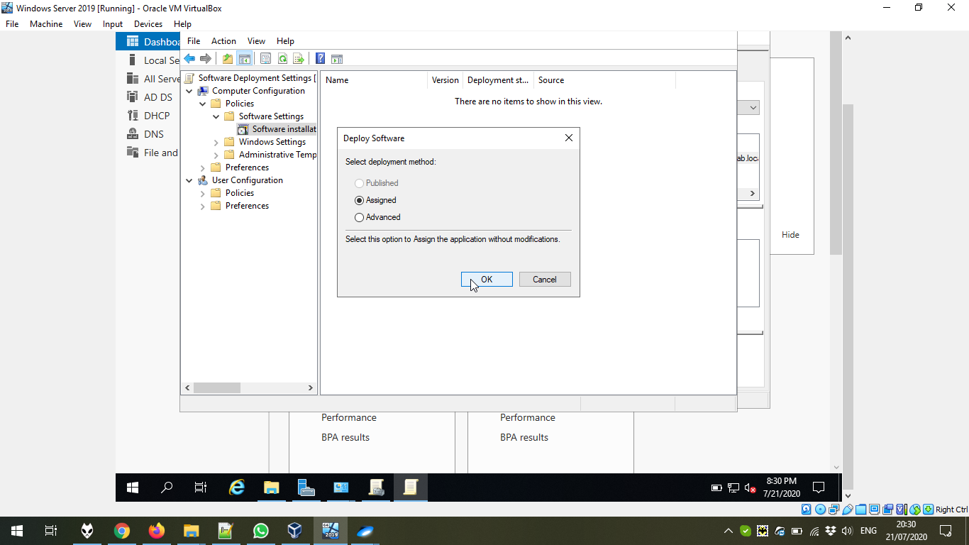

The package is added:

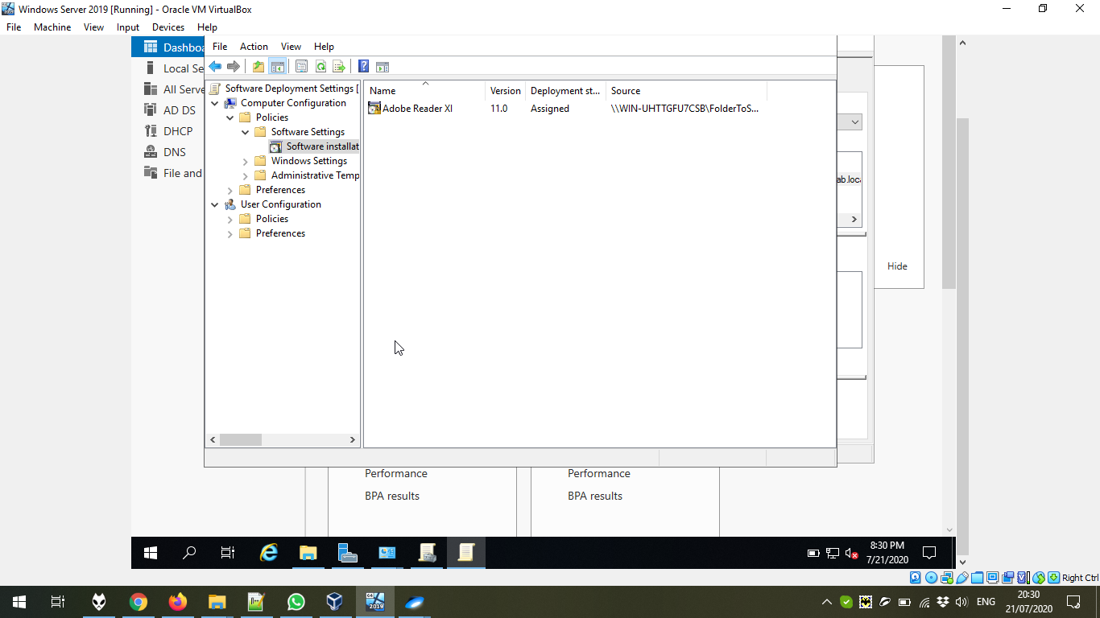

After entering the domain, we see Adobe Reader already installed:

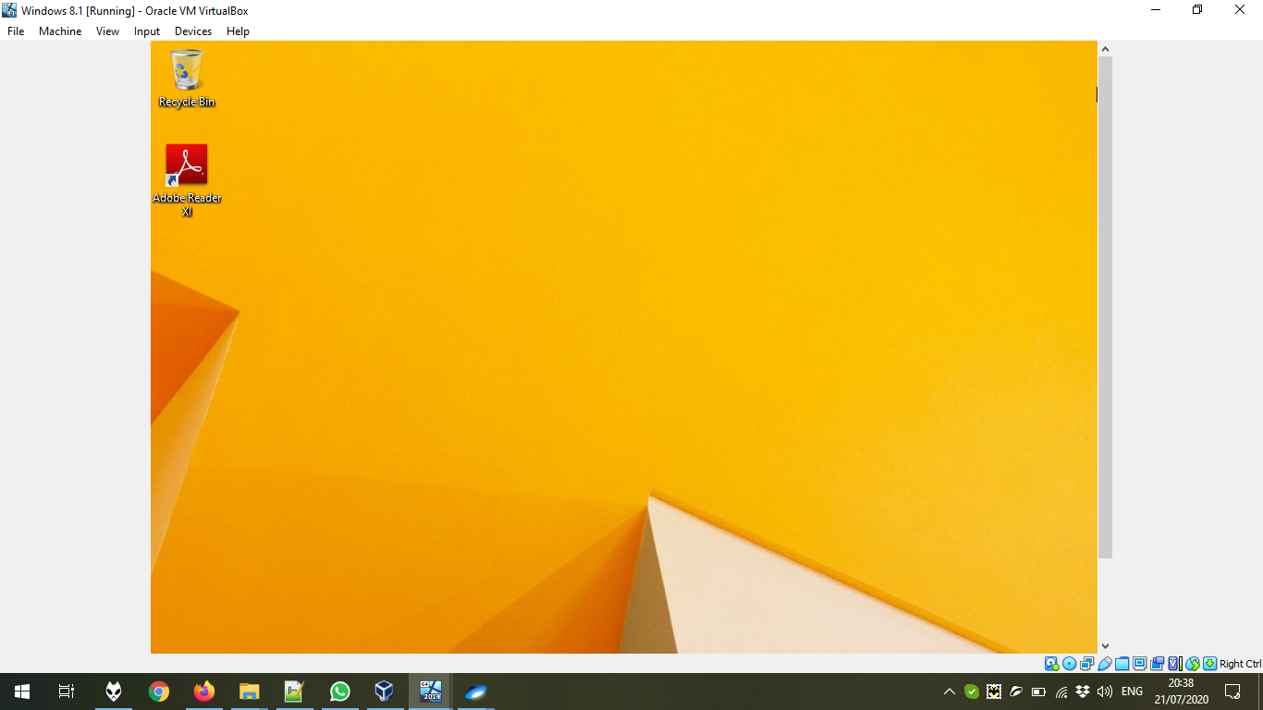

Now, let’s create some Internet Policy for Users:

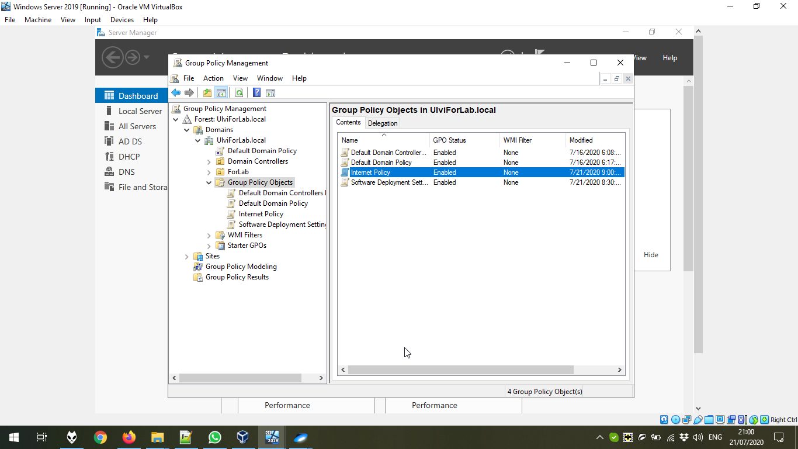

We go to User Configuration → Preferences → Windows Settings → Registry and add some registry entries by New → Registry Items.

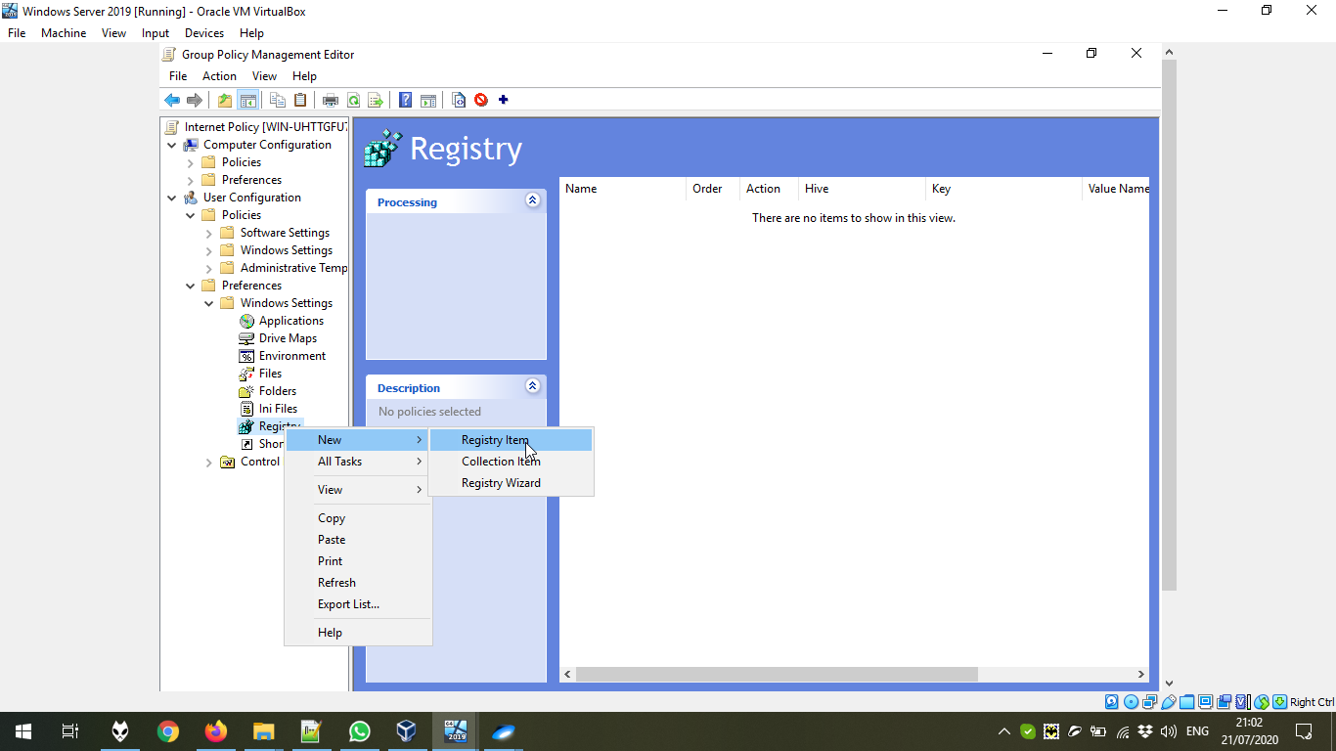

In **HKEY_CURRENT_USER\Software\Microsoft\Windows\CurrentVersion\Internet Settings**, we should add 4 records. The name, the value, the type might be seen in the screenshots. The first record – Enabling Proxy.

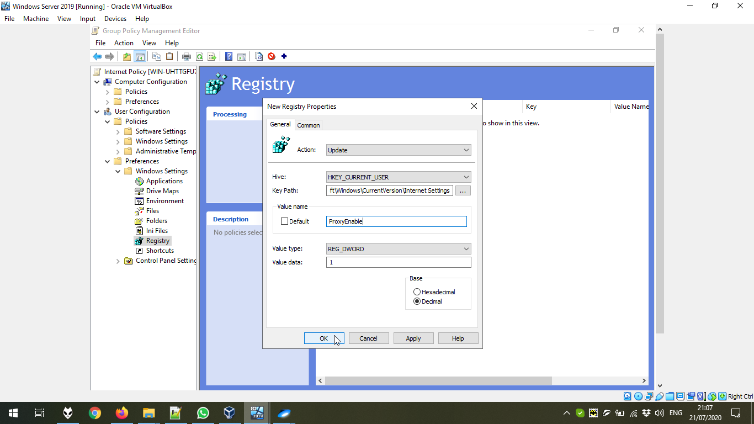

The second record – Setting the proxy server as localhost to check the queries in HTTP requests from the policy:

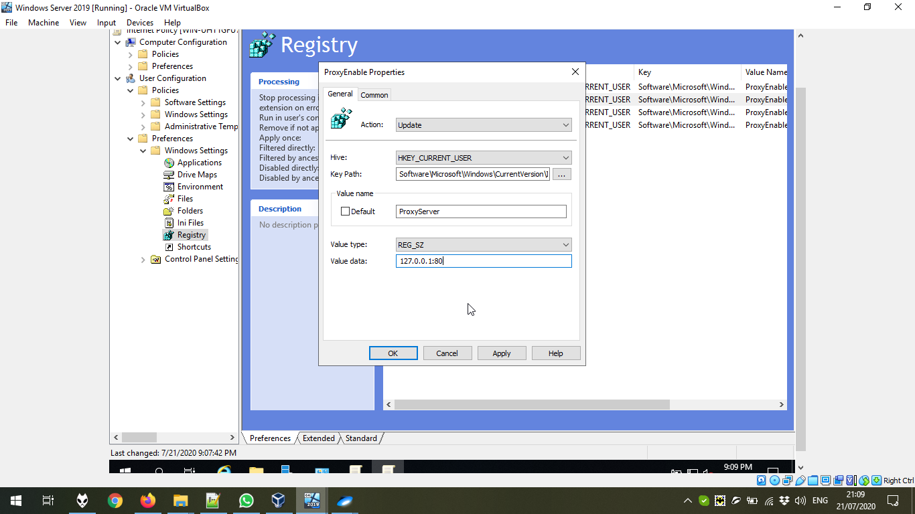

The third record – adding the available sites and bypassing the calls to the local servers:

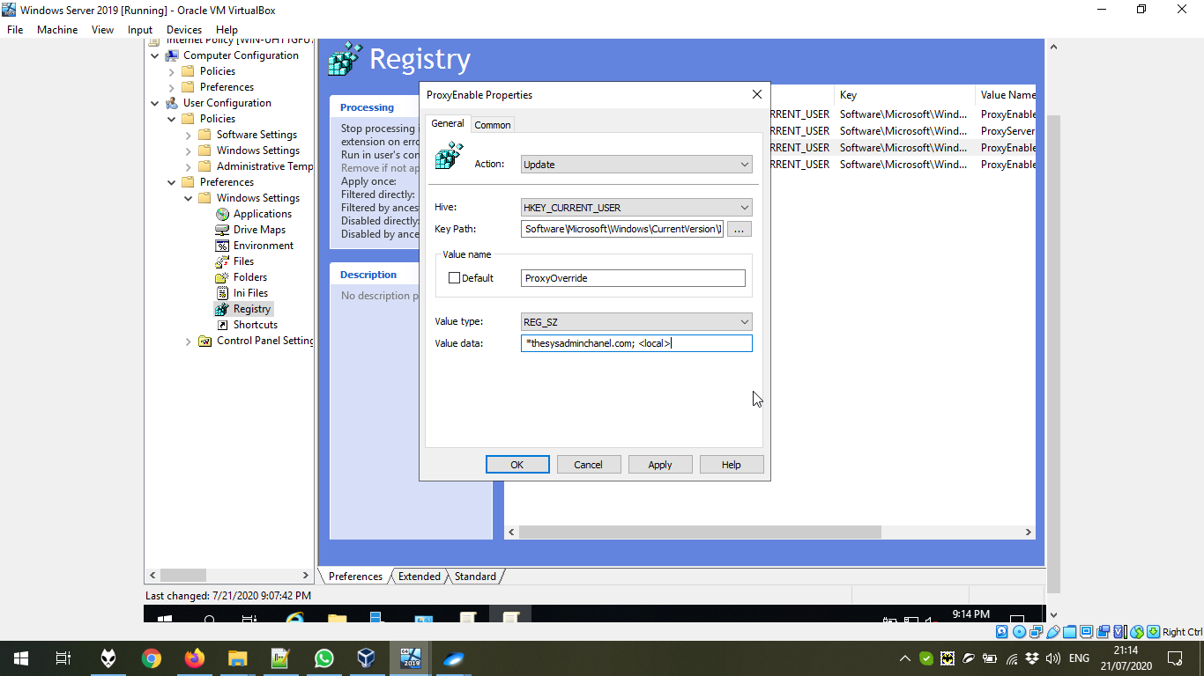

The fourth record – to avoid detecting proxy settings automatically:

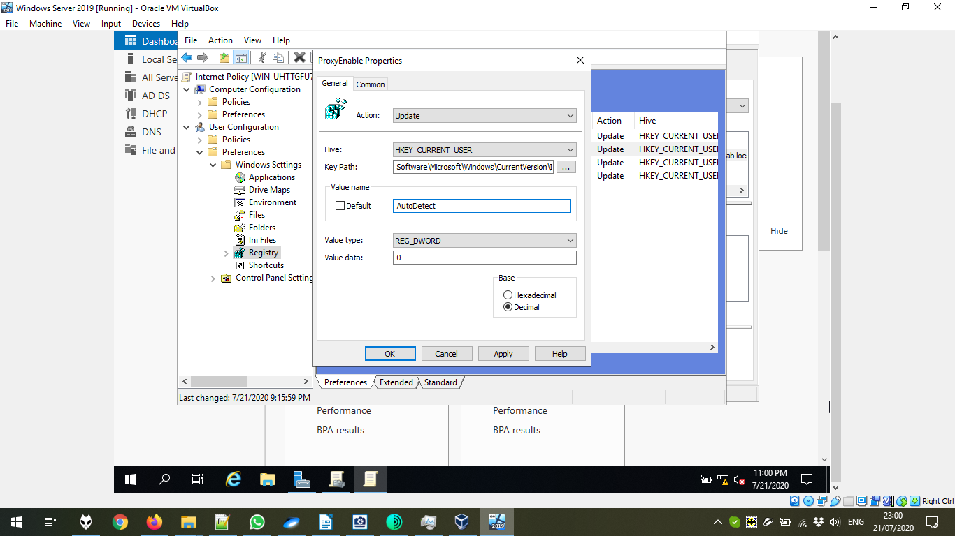

Now, it is important to restrict proxy options. We go to User Configuration → Policies → Administrative Template Policy Settings and enable two options.

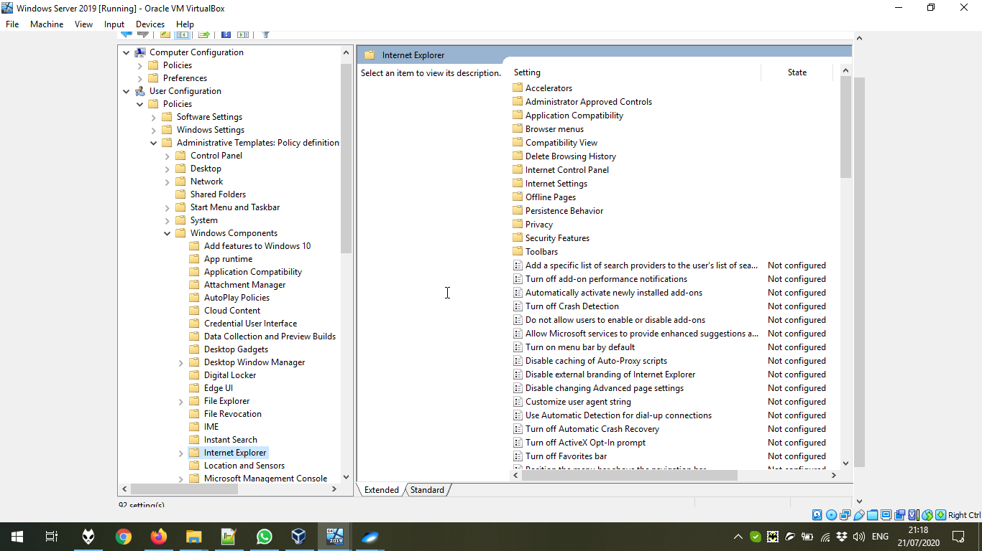

We can change the options by Edit. The first option is Disable changing Automatic Configuration Settings.

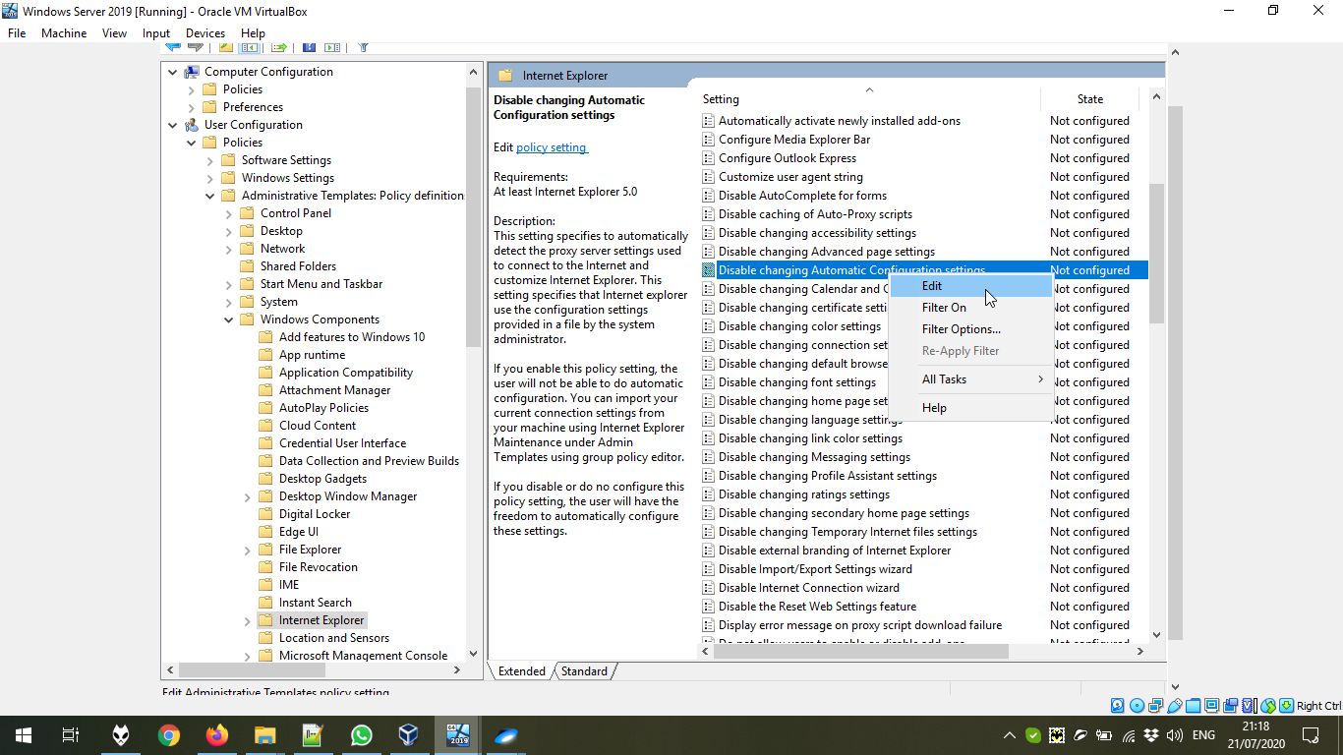

We set it to Enabled:

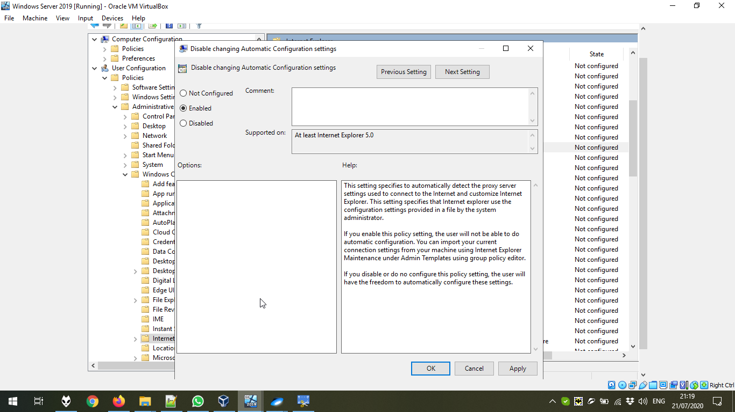

Another option to set Enabled is Prevent changing proxy settings:

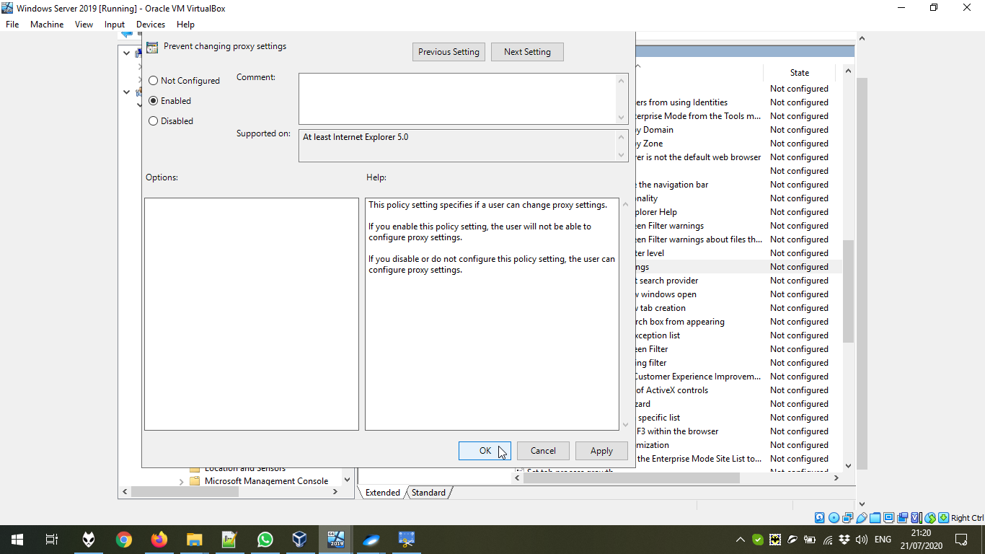

Now, we link the existing Policy to the ForLab Users (it could be done in the first steps).

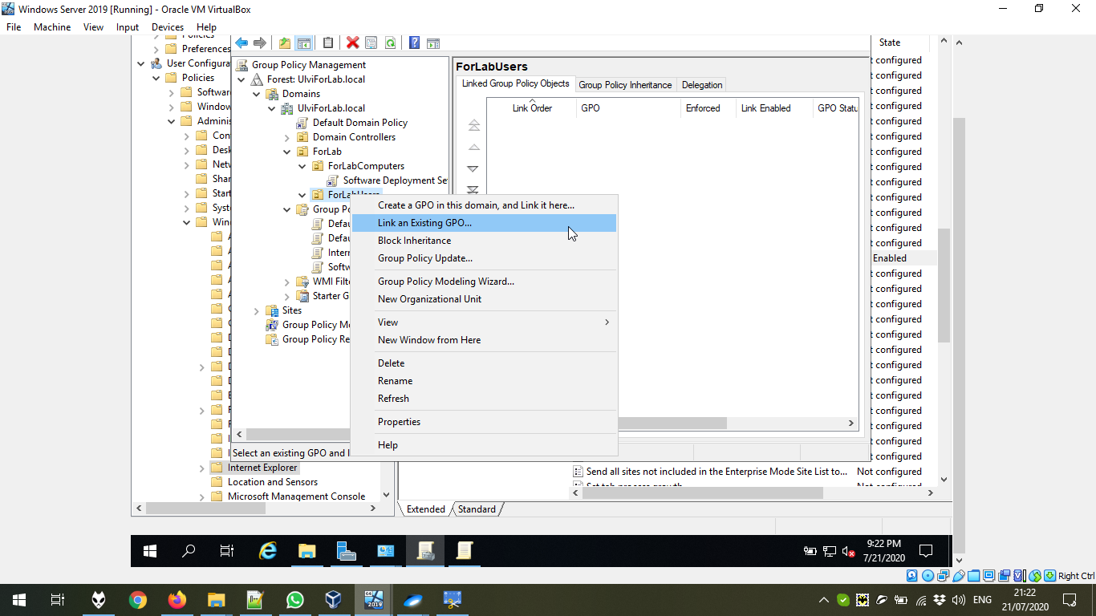

We choose the Internet Policy:

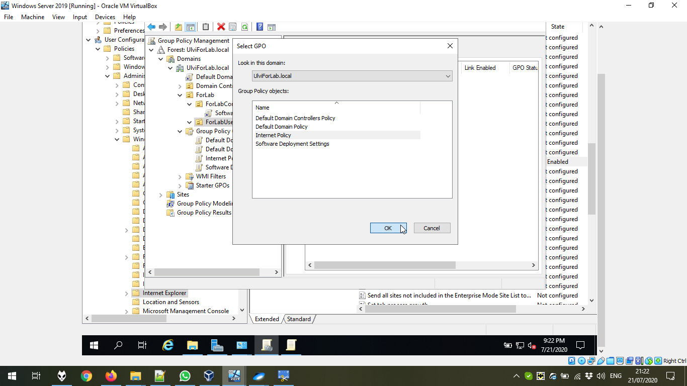

Now, we can test all settings in Internet Explorer. Unfortunately, due to the problems with the program in Windows 8.1, the author could not test it. But according to the provided tutorial (**https://www.youtube.com/watch?v=00t18BsXl9I**), it should have worked.

